**UNIVERSITI TUN HUSSEIN ONN MALAYSIA**

**STATUS CONFIRMATION FOR UNDERGRADUATE PROJECT REPORT**

**MES Factory Software Implementation and KI factory explanation**

**ACADEMIC SESSION: 2023**

~~We, Moritz Hoehnel and Mattis Ritter agree to allow this Undergraduate Project Report to be kept at the Library under the following terms:~~

1. This Undergraduate Project Report is the property of the Universiti Tun Hussein Onn Malaysia.

2. The library has the right to make copies for educational purposes only.

3. The library is allowed to make copies of this report for educational exchange between higher educational institutions.

4. ** Please Mark (√)

√

|  |  |
| --- | --- |
| CONFIDENTIAL | (Contains information of high security or of great importance to Malaysia as STIPULATED under the OFFICIAL SECRET ACT 1972) |
| RESTRICTED | (Contains restricted information as determined by the Organization/institution where research was conducted) |
| FREE ACCESS |  |

Approved by

(WRITER’S SIGNATURE) (SUPERVISOR’S SIGNATURE)

Permanent Address:

NO19A, Jalan Kencana,

83300 Pura Kencana

BATU PAHAT,

JOHOR

Date: ______________________ Date: ______________________

NOTE:

** If this Undergraduate Project Report is classified as CONFIDENTIAL or RESTRICTED, please attach the letter from the relevant authority/organization stating reasons and duration for such classifications.

**MES Factory Software Implementation and KI factory explanation**

Moritz Hoehnel

Mattis Ritter

A thesis submitted in partial

fulfillment of the requirement for the award of the

Bachelor’s Degree of Mechanical Engineering with Honours

Faculty of Mechanical and Manufacturing Engineering

Universiti Tun Hussein Onn Malaysia

August 2023

I hereby declare that the work in this project report is my own except for quotations and summaries which have been duly acknowledged

Student : ……………………………………………………

Moritz Hoehnel and Mattis Ritter

Date : ……………………………………………………

Supervisor : ……………………………………………………

Prof. Madya Ir. Dr. Low Cheng Yee

Co Supervisor : ……………………………………………………

Prof. Madya Ts. Dr. Zakiah Binti Kamdi

ACKNOWLEDGEMENT

We would like to use this space to give a special acknowledgment for Dr. Low Cheng Yee, who always supported us in every matter.

We would like to also thank all the persons working in the UTHM-Frauenhofer IEM Innovation Lab. It was great working together with very helping people. It was a great experience being part of the project learning factory.

ABSTRACT

This is where you should start your writing of your abstract. Don’t change any of the setting.

ABSTRAK

Di sini anda sepatutnya memulakan penulisan abstrak. Jangan ubah *setting* yang telah dibuat. Jika penulisan abstrak ada melibatkan penggunaan ayat bahasa Inggeris, ayat tersebut mesti di *Italic*. Rujuk format penulisan tesis.

CONTENTS

TITLE i

DECLARATION ii

ACKNOWLEDGEMENT iii

ABSTRACT iv

ABSTRAK v

LIST OF TABLES a

LIST OF FIGURES b

LIST OF SYMBOLS AND ABBREVIATIONS c

LIST OF APPENDICES d

CHAPTER 1 INTRODUCTION 2

1.1 Background Study (use Heading 2 style) 2

1.2 Problem Statement (use Heading 2 style) 2

1.3 Aim 2

1.4 Objectives 2

1.5 Scope of Study 2

1.6 Significant of study 2

CHAPTER 2 LITERATURE REVIEW 2

2.1 Using Captioning and Cross Referencing 2

2.1.1 Captioning 2

2.1.2 Cross Referencing 2

2.1.3 Updating Tables of Contents, Lists of Figures and Captions 2

CHAPTER 3 METHODOLOGY 2

3.1 Title (use Heading 2 style) 2

3.1.1 Title (use Heading 3 style) 2

CHAPTER 4 RESULTS AND DISCUSSION 2

4.1 Title (use Heading 2 style) 2

4.1.1 Title (use Heading 3 style) 2

CHAPTER 5 CONCLUSION AND RECOMMENDATIONS 2

5.1 Title (use Heading 2 style) 2

5.1.1 Title (use Heading 3 style) 2

REFERENCE a

APPENDIX b

LIST OF TABLES

2.1 Put a table title (use ‘Caption’ style) 2

LIST OF FIGURES

2.1 Gas Turbine (use ‘Caption’ style) 2

LIST OF SYMBOLS AND ABBREVIATIONS

|  |  |  |
| --- | --- | --- |
| $$α$$ | - | Angle of attack |
| $$η_{th}$$ | - | Thermal efficiency |
| DCAM | - | Department of Civil Aviation of Malaysia |

You should start with explanation of symbols before abbreviation

LIST OF APPENDICES

|  |  |  |  |
| --- | --- | --- | --- |
| **APPENDIX** | **TITLE** |  | **PAGE** |
| A | (Put your title here) |  | xx |

# INTRODUCTION

## Background Study (use Heading 2 style)

“The fourth industrial revolution is accelerating more and more. The foundations for a completely connected ‘smart factory’ are set. Digitalization, robotics, artificial intelligence […]. Today, these developments are changing industrial production fundamentally. […] Physical and digital processes are becoming increasingly intertwined. This also includes networking with customers: Their needs and demands are and remain the guiding principle of all of the company's work.” (Mercedes-Benz Group: <https://group.mercedes-benz.com/innovation/case/connectivity/industry-4-0.html>, 20.05.2023). The Mercedes-Benz Group, one of the world’s leading car manufacturers, stating that the current industrialization is having an increasing effect. As three main pillars they name the digitalization, advancing robot technology and artificial intelligence. All these pillars get more and more integrated into production processes, as they have positive effect on production costs.

One goal of Industry 4.0 is to connect workers and machines. Digitalization is providing a platform to collect production data from machines as well as humans. They can be analyzed and translated into languages machines and humans understand. Advancing robot technologies are helping to support and take over production steps. Especially those that human can not handle, as example working in a hot environment. The third pillar, Artificial intelligence, is advancing analyzing the processing of production data.

The goal of this project is to work on a factory simulation that is capable of all the previous requirements for a future factory. The factory is completely operated by robots, to establish one pillar. For the first part of this project a Manufacturing Execution System (MES) should be established. It is used to collect the sensor data, safe it to a cloud and then send it to inform the workers and machines that are part of the production. This means that it takes the pillar of Digitalization. The second step of the project shall establish the third pillar, the artificial intelligence. It should be used to analyze the production data.

Apart from optimizing the production itself, the Mercedes-Benz Group outlines that the need for providing information to the customers also becomes more important. The MES has matching options for this purpose and shall be used to provide production information.

## Problem Statement (use Heading 2 style)

Figure x.x: Fischertechnik Smart Factory

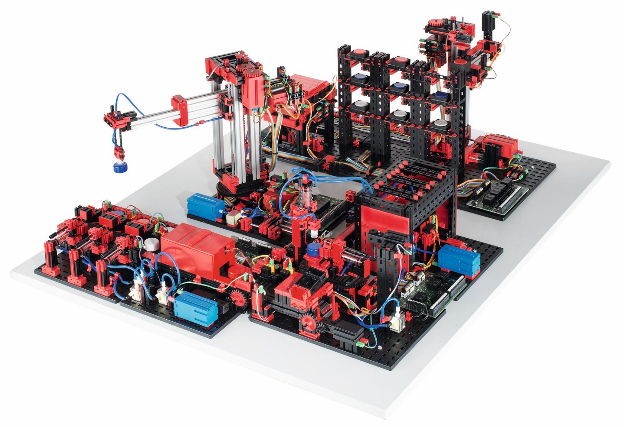

vacuum gripper robot

high-bay warehouse

sorting line with color detection

multi-processing station with oven

https://www.fischer.group/-/media/corporate/international/presse/images-presseinformationen/fischertechnik/2017/170926-fischertechnik-fabrik_simulation.ashx

The Fischertechnik Smart Factory is used in the project. It is a learning factory that comes with many features and in the following a typical process and how to keep track of the workpiece is described.

When the process is started, the transport arm of the high-bay warehouse (HBW) moves to the storage system, picks up the wanted workpiece and places it in the output station. There it is conveyed to the pick-up position of the vacuum suction pad. This process can be monitored with the end-switches of the transport arm and the light sensors of the output station. When the end-switch of the transport arm is released a workpiece is collected and when it is pressed again it is deployed to the output station. There two light sensors detect whether the workpiece is at the end or start of the conveyor belt.

The vacuum gripper robot (VGR) picks up the workpiece from the output station of the high-bay warehouse (HBW) and places it on the slide of the oven of the multi-processing station with oven(MPO). When the end-switch of the VGR is released this process has started and as soon as the light sensor of the slide is triggered the workpiece has reached the MPO. There the workpiece is pushed in, fired and moved out again. The transport carriage with vacuum suction pad then transports the workpiece to the milling machine. There, the workpiece is placed on the rotary table and when it the end-switch of it is pressed the MPO comes to its end.

After the milling process, the workpiece is pneumatically pushed onto the conveyor belt of the sorting line with color detection(SLD). On the conveyor belt, the workpiece passes through a color recognition system. Depending on the color detected, the workpiece is pneumatically pushed onto the corresponding chute. Once more the light sensors provide information of the status of the sorting line.

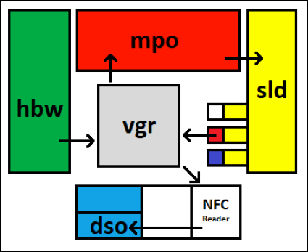

Figure x.x: Schematic plan of the Smart Factory

Table x.x: Start and end of each station

|  |  |  |
| --- | --- | --- |
| Station | Process | Sensor |
| HBW | Start collecting workpiece | End-switch released |
| Workpiece leaving output station | Second light sensor triggered |
| VGR | VGR started | End-switch released |
| VGR finished | Light sensor of slide triggered |
| MPO | Workpiece deployed to MPO | Light-sensor of slide triggered |
| Workpiece leaving MPO | End switch of rotary table |
| SLD | Workpiece deployed to SLD | Pneumatic valve activated |
| Workpiece sorted | Light sensor of chute triggered |

The Smart factory is connected to a PLC from Beckhoff and controlled with their software TwinCAT 3. The input and output data od the sensors and actuators has to be written into a server to make it available for the arcstone MES.

## Objectives

This chapter provides the specification of the project. It will be defined what is needed to be done to complete the project.

#### Scope (of the software product)

The first task is to establish the MES Software to work with the learning factory. The second task is to explain how to make the KI-Campus factory Software work with the factory in the laboratory.

#### Explanation of terms and / or abbreviations

|  |  |
| --- | --- |
| ID | Is the identification number of a specification. |
| Pr. | Is the priority of a specification. It specifies whether a goal has to be achieved or not.  A: Has to be fulfilled (Verification needed).  B: Should be fulfilled  C: Can be fulfilled |
| MES | Manufacturing execution system |

#### Overview (How is the document structured?)

In the following chapter a general description of the project will be done. It will give an overview of the tasks. In the second part specific requirements will be clarified.

### general description (of the system)

a. Product functions (a summary and overview)

For the first part of the project a MES software is used. It is used to digitalize manufacturing processes. For worker of the manufactory it should provide instructions. Therefore a workflow for the whole production process will be implemented. Customers should be supplied with information about the state of the production. The information provided to the costumers shall be of such a nature to help them classify when the product will be ready. A person that oversees the production should have a dashboard with collected data sets.

For the KI-Campus learning factory a set of explanations will be created. This will include a user manual and a workshop in which the functions will be gone through. Furthermore, it will be discussed how to implement the Software to the factory.

#### Product perspective

The factory is shown on an exhibition table. The results of the implementation of the MES Software can be accessed via a PC and a screen. For show purposes it is advised to locate the screen right next to the factory.

The KI-Campus factory learning material will be given digitally. The workshop will be held face to face.

#### User characteristics (information about expected users, e.g., education, experience,expertise)

The expected users of the MES software divide into three groups: Worker, Customer and Manager.

The workers expertise will be to use the PLC software. He has expertise for all the steps of the factory. He will need to learn how to follow instructions of the MES workflow. He probably has no higher education and won’t be able to implement any changes to the software.

The manager will have higher education. He has experiences with complex software. He needs to overview that the MES software is running correctly. He also needs expertise on how to interpret data as he will need to have a look onto the data sets of the dashboard.

The customer is a coworker of a other company that works in the department of purchase and sells. He has experiences in using ordering software. He need to apply these expertise to access the data provided to him.

#### Design constraints (for the developers)

Not all parts needed for KI-Campus factory are available. This could hinder the connection between the KI applications and the factory.

## Scope of Study

a. functional requirements

i. MES software

|  |  |  |  |  |
| --- | --- | --- | --- | --- |
| ID | Name | Description | Verification | Pr. |
| A.01 | Workflow | With arc.ops a workflow has to be created for the hole factoring process. | Ended workflow | A |
| A.02 | Workflow | Further processes can be implemented for product personalization | - | C |
| A.03 | Data collection | With arc.quire data of the factory must be demanded | Software verifies connection | A |
| A.04 | Database | A database needs to be created, that is capable to store all important data. | Load data into database | A |
| A.05 | Database | Data from the factory must be stored into the database. | Request list of database. | A |
| A.06 | Flow | A flow needs to be created with arc.flow | Finished Flow | A |
| A.07 | Flow | Data has to be processed and analyzed. Important sensor values will have an allocated meaning. | Understable data | A |
| A.08 | Dashboard | Data need to be put into a dashboard. Important information about the manufactory need to be shown. | Reviewing dashboard on screen | A |

ii. external interfaces

|  |  |  |  |  |
| --- | --- | --- | --- | --- |
| ID | Name | Description | Verification | Pr. |
| B.01 | Screen | To access the MES software a display is required. | Plug in display | A |
| B.02 | Connection | All systems need to connect to the UTHM network | Confirmation of established connection | A |
| B.03 | Connection | The factory data needs to be transmitted to the UTHM server | Access data | A |
| B.04 | Connection | The arc.quire software needs to connect with the UTHM server. | Data can be loaded | A |
|  |  |  |  |  |
|  |  |  |  |  |
|  |  |  |  |  |

iii. Output

|  |  |  |  |  |
| --- | --- | --- | --- | --- |
| ID | Name | Description | Verification | Pr. |
| C.01 | Dashboard | Factory information is provided | Dashboard review |  |
| C.02 | Workflow | The coworker is provided with information about the next production steps he needs to execute. | Coworker view review |  |

iv. KI learning factory

|  |  |  |  |  |
| --- | --- | --- | --- | --- |
| ID | Name | Description | Verification | Pr. |
| D.01 | Information gathering | Course of KI learning factory needs to be attended | 100% attendance | A |
| D.02 | Doing tasks | Task during the course should be done, within the possibilities of equipment. | - | B |
| D.03 | Manual | Creating an manual for the use of the KI factory software. | Report finished | A |
| D.04 | Workshop | Prepare lessons in which interactively the information is provided | Finished workshop | A |
| D.05 | Connection | Data of the factory should be loaded into the database. | - | B |
| D.06 | Data | Transferred data should be analyzed using KI software | - | B |
| D.07 | Connection | A connection to the controller of the factory can be established | - | C |
| D.08 | Controlling | The factory may be controlled by the KI software | - | C |

iv. Environmental conditions

b. non-functional requirements

|  |  |  |  |  |
| --- | --- | --- | --- | --- |
| ID | Name | Description | Verification | Pr. |
| F.01 | Software | Usage of arcstone arc.ops | All PCs need to be controlled to always use the latest version of the software | A |
| F.02 | Software | Usage of arcstone arc.quire | A |
| F.03 | Software | Usage of arcstone arc.flow | A |
| F.04 | Software | Usage of Microsoft SQL database manager | A |
| F.05 | Software | Anaconda for python | B |
| F.06 | Server | UTHM server is to be used |  | A |

# LITERATURE REVIEW

This chapter will explain the theory of the project’s subjects. The explanations are based on literature that can be found in the literature list. The first part of this chapter will cover MES in general. The second part is given the basics for the Artificial Intelligence Lernfabrik.

## MES

MES technology has come a long way since its inception in the 1980s and is now a vital component in the success of manufacturing companies around the world. The following chapter will cover the definition of a MES, its functionalities and how it is embedded into an enterprise. After that the role of MES in the context of Industry 4.0 will be evaluated.

### Functionality of a MES

MES is designed to improve operational efficiency and increase overall productivity by giving manufacturers insight into their production processes and providing them with tools to help optimize workflows. This is achieved by monitoring all aspects of the production process in real time. That is why the production process has to be fully digitized before you can apply a MES. In the best case all sensor data and actuator states are available at real time, otherwise additional data has to be provided manually.

Nowadays the functionality of a MES is described by the combination of three functional scopes. Those areas have to work hand in hand to create a high performance MES and enable a well-timed and effective manufacturing control.

First there is the function group production, where data acquisition plays the most important role. For production, data order and person related times and quantities are recorded, but also machine data is collected to manage machines and other operational resources. Moreover, operational data such as order and personnel timing an amounts are acquired. Other possible applications of a MES in the connection with production are tool and resource management, where tools and other auxiliary materials are managed, material and production logistics, where information about currently circulating material is provided, energy management and many more.

When it comes to human resources a MES should be able to handle time recording, time management, personnel resource planning and wage calculation. Furthermore, short-term manpower planning and escalation management can also be use cases for a MES.

For the third field quality assurance different mechanisms like production inspection, complaints management, testing and measurement data acquisition can be implemented into a MES.

Lots of associations have developed standards to describe the requirements of a MES. As defined by the VDI (Verein Deutsche Ingenieure, *engl*. Association of German Engineers) in the guideline VDI 5600 the tasks of a MES are the following:

* Detailed planning and detailed scheduling control
* Operating resources management
* Material management
* Personnel management
* Data acquisition and processing
* Interface management
* Performance analysis
* Quality management
* Information management
* Order management
* Energy management

Furthermore, the context of the MES in the complete enterprise is described in these standards, where the attempts in the VDI 5600 and the ISA 95 with three levels stacked on each other.

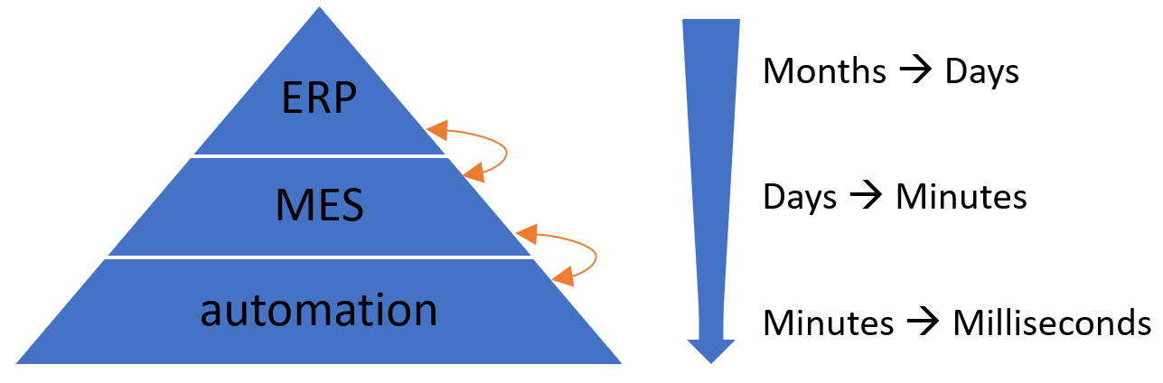

Figure 2.x: Architecture of an enterprise with MES

As shown in the figure the MES is located in between the ERP (enterprise resource planning) and the automation on shopfloor level. Furthermore, the time horizons of the different stages get significantly shorter from top to bottom. As in the ERP long- or mid-term decisions are made, the time period of interest varies from months to days, whereas for the MES single days to minutes matter. For the shopfloor level, where the actual production happens, it can even depend on milliseconds.

Since the MES has interfaces with lots of other systems, it acts like a hub for the data. The ERP provides the base-data such as orders, quality requirements and capacity planning that needs to be saved and processed in the MES. But the MES also has to receive data from the production on shopfloor level including sensor values, process data, machine status, counter ticks or measurements that get processed to business relevant units. It is also possible that the MES provides specific data for the production for instance process value specifications, target values or recipes. When it is not possible to access these data automatically, workers have to insert them manually. When the MES is seen as a hub, it is important that it is integrated horizontally as well as vertically, which means that the information is distributed on the MES level and also throughout the different levels of the pyramid.

When using a MES a database, either an external one or the MES itself, with high requirements is needed. Data has to be consistent, plausible and complete, which is also relevant for data acquisition. Furthermore, the database has to meet various security aspects so that the production is not endangered in case of power outage and other problems.

### MES in the context of Industry 4.0

The term Industry 4.0 has been circulating in the manufacturing industry for a while, but there are different approaches to revolutionizing industrial production. It is agreed that the use of information technology and increased networking can significantly improve the efficiency of industrial production, potentially increasing productivity by more than 30%. However, achieving productivity gains requires the use of applications that take advantage of these new technologies and changes in organization such as MES.

Many visionaries dream of the ultimate networking of all resources and systems in manufacturing, where each machine is aware of its capabilities and each material knows which product it will become and for which customer it is destined. While this vision has evolved, a more practical approach seeks for each resource to be able to communicate with every other resource, allowing for early error detection and an increase in the flexibility and intelligence of the machines. Decentralized decision-making will become more common, but human experience will always be needed for final decision-making. This vision is known as a Smart Factory.

The concept of a Smart Factory presents new requirements for manufacturing software such as MES. IT systems need to become more flexible in order to adapt to short-term changes in manufacturing processes easily. The increasing interconnectivity generates huge amounts of data that require semantic structuring to become valuable. This "Big Data" must be processed in real-time to derive intelligent and useful insights. Industry 4.0 has to include human involvement and concrete use cases for optimal success.

The basic principles of a MES as defined in VDI guideline 5600 provide a good starting point for the Industry 4.0 era. In particular horizontal integration and comprehensive penetration of the company are of the most important issues here. The collection of data in production, their aggregation and also the processing and displaying in real time are essential for the success of a smart factory. However, there is much more to it than the processing of data and measured values into meaningful information. In the future modern companies will depend much more on the integration of all functions and modules across all elements involved in production. In addition, the importance of cross-system data exchange will increase, which is therefore another task a MES must fulfill.

In summary, it can be stated that MES systems would be ideally suited as a central information and data hub in a smart factory. But in order to do so in perfection today's systems still need to be further developed. Still the basic approach of the MES idea is already heading in the right direction. The goal must be to synchronize all systems and functions involved in production. Transparent data exchange is the basis for a functioning future scenario. This does not just mean the pure distribution of data, but also application-related preprocessing or aggregation. For example, ERP systems only need final summary values and not the comprehensive detailed data from the individual status messages at the machine. An MES system, as the central hub, has the task to provide each user and each system with exactly the data that is expected or required.

The developments and enhancements of the MES 4.0 concept aim to satisfy market and customer demands, such as mass customization and resource efficiency, to ensure manufacturing companies remain competitive in an increasingly globalized market. MES 4.0 provides flexible software tools to support the individualization of mass-produced products and improve efficiency, which is crucial for maintaining and expanding market leadership in a high-wage, highly automated region. The concepts of Industry 4.0 and MES 4.0 will promote sustainable efficiency in manufacturing in the long term.

## Artificial Intelligence

So far, the factory is controlled by a PLC software. This software allows the developer to set clear instructions what the factory and each machine does. Instructions are worked through precisely. It furthermore needs to be controlled by workmen. The production process is started, viewed and stopped by humans. Furthermore, the quality of products needs to be screened. For a company this always means to pay wages. But how avoid these costs?

With “[the] branch of computer science that is concerned with the automation of intelligent behavior” (Luger and Stubblefield, 1993), which is called artificial intelligence (AI). This could help to take over the task of the mentioned steps of work.

The factory is supposed to be monitored and controlled by artificial intelligence. While AI comprehend many ways of implementations, this project is supposed to use neuronal networks. This chapter will review neuronal networks.

### Neuronal Network in general

When talking about neuronal network it is meant to have an artificial neuronal network. The idea is to create software that works similar like a human brain, a natural neuronal network. This network gives us our intelligence. It helps us to train our abilities, physically and more important mentally. We can adopt to situations and changes.

But how to build such a system? A computer has an architecture not matching with the brain. It is basically a calculator that can execute software which is based on mathematics. The attempt is to analyze human brain and to create models that reflect the brain. The network consists of many small entities, that are similar like the neurons. They are working like single information storages, powered by electric voltage. As messages reach a neuron, also electrical energy is sent. The voltage level is rising. At some point there is too much energy in a neuron and it will reach out and sends its information. But where to?

**“What fires together, wires together”** (Hebb, 2002) is a quote describing that neurons often reach out to each other will connect. The more often they communicate the stronger their connection will be. For an artificial neuronal network it should work similar. When raw data is put in a new system, there is no connection between the entities. The computer then need to find connections. Hebb is describing the idea of how it’s done: Data often colliding, will have some kind of link. This is how the computer can derive clusters. Once this clusters are established it can be used to solve tasks. The more tasks it solves, the more information the system can collect. This information can also lead to an evolvement of the clusters.

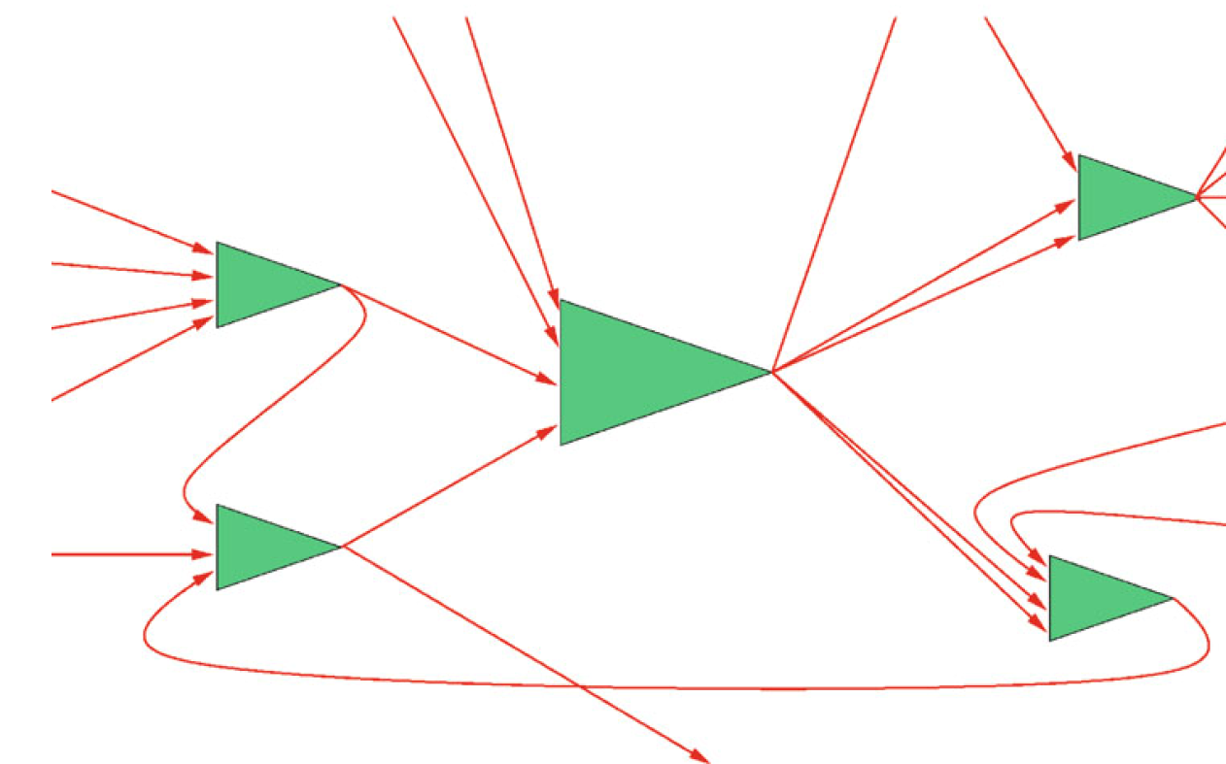

Figure 2.x: Model of network (Ertel, 2021)

The above figure above represents the network. The green triangles are the neurons connected by wires. The following picture shows how this is implemented.

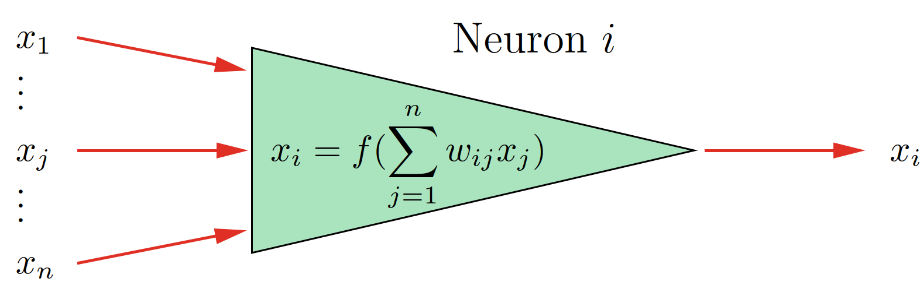

Figure 2.x: Mathematical Neuron (Ertel, 2021)

The input voltage of each wire is represented by variables named $x_{j}$ in the picture. The higher the voltage value of the human brain is, the higher the value of $x_{j}$ is in the mathematical model. The factor $ω_{ij}$ is fixed to each $x_{j}$ and represents how strong the connection to the respective previous neuron is. The better the connection, the more electrical power will go through. Despite this being a factor, its value can change, if the connection is changing as result of an adapting process. The product of each input and its factor will then be summed up. This is the output value $x_{i}$.

Despite its called learning network in most networks the input data is processed through fixed calculations. In most cases it is a kind of matrix multiplication or applying filters and mask. It is also possible to several steps of calculation. That’s why an expert is required, who knows what the network is used for. The expert can then create the processing formulas.

What is it the network is learning then? It is the adjustment of the factors $x_{j}$. When saying the network is being trained, it means that the artificial network does the calculation of the factors based on the received input data. With that the network is then able to detect patterns.

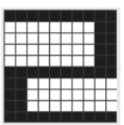Ein Bild, das Quadrat, Rechteck, Text, Kreuzworträtsel enthält.

Figure 2.x: Pattern of number 2 (Ertel, 2021)

In the above picture an example of pattern image recognition is shown. The network is trained to detect numbers. It is trained as an example with the number 2 on the left side of the figure. The network should then be able to recognize the 2. What makes a neuronal network special, that it is not just able to recognize the same image of the number, but also an image with changes. That is necessary in the real world as there are for example disturbances. This is shown on the right side of the figure. Some pixels of the 2 are not in place. If there was a standard recognition, it would fail to find the 2, but we want to recognize it as a 2. That is where the neuronal network comes in to play. What the network does is applying filters and masks to the picture. This will be done until the pattern of the 2 is recognized.

Another example is face recognition. If you take a picture of a person. The next day you want to recognize the face, it will be hardly possible. Because every day a person looks a bit different. And over the years a person’s face can change immensely. The network still needs to be able to recognize the pattern of a human face. For that a series of pictures is required to enable the network to learn. It then can find similarities and use them to recognize a change face.

The examples just considered image processing. But neuronal networks can be used in different areas. In the human brain, different parts are responsible for different tasks. So every part is structured differently to match its requirements. For artificial networks it is similar. Different networks suit different tasks. That’s why there are many different models that try to attempt to rebuild a part of the brain. Each model has its benefits an application its suits. For our project it will be the convolutional neuronal network and the recurrent neuronal network.

### Convolutional Neuronal Network

The issue of most networks is that they have a vast amount of data as input. Processing all of it in just one step would take very long. This is addressed by having several steps of processing. In most networks the first step is to extract attributes. These are often referred as preprocessing layers. They often consist of filters, similar like described above capable of learning. With every layer different things can be extracted. If you take image processing as an example, there is one layer to recognize edges of the picture and a layer to extract a face. In most cases the more layers you have the more attributes you can extract. In a second step attributes will be interpreted.

In a convolutional neuronal network (CNN) most of the filters are based on the mathematical convolution. The advantage of the convolution is that it reduces the number of the factors. This helps fasten up the calculation operation.

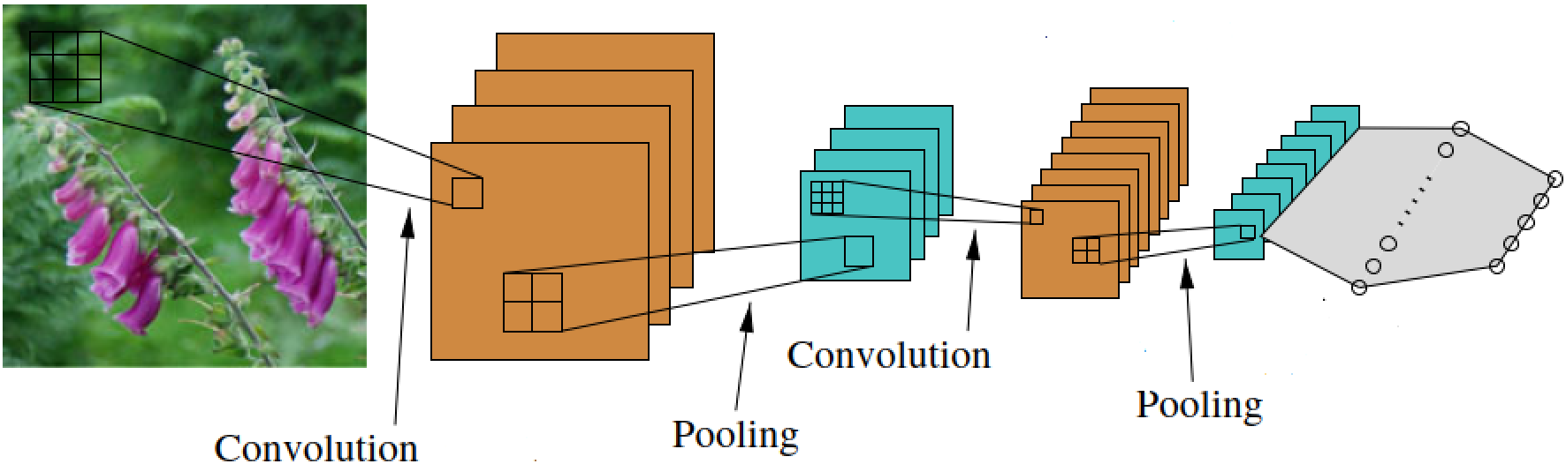

Figure 2.x: CNN working principle (Ertel, 2021)

The figure above visualizes the working principle of the filters for image processing. The input is a picture of flowers. The picture then will be filtered by using the convolution. The result is a smaller picture with highlighted attributes. The next step is pooling. Information that are similar get bundled here. This data reduction helps to safe storage space and ultimately processing time. The two steps will be repeated. The goal is to have a smaller set of extracted data. This get inserted into the neurons of the network.

The whole process is complex. Several mathematical functions need to be used the right way. Additionally, as there are less factors, they need to be more precise. This is leading to long training times. It also requires more validation, to check if the learned factors are precise enough. Otherwise, a to big error in factor value can lead to misinterpretation.

Nowadays, scientist and engineers need to have a huge knowledge about every aspect of the network to make it work correctly. It often requires a lot of experience to know which filters to use and how to order them. Also, on the mathematical side expertise is required. The filters can consist of many different mathematical operations. This can also lead to long development times.

The results of working convolutional neuronal networks are satisfactory though. For example, face recognition has not been possible with classical computation. Despite it is easier to imaging this kind of network is used for image processing it is also possible to use it in other branches. It just gets more abstract, as the constructor of the network needs to be able to create filters that work for data sets that come as example form a factory.

### Recurrent Neuronal Network

The second network that this chapter covers is a recurrent neuronal network. Compared to the human brain this is working like the short-term memory. It is capable of remembering data input for a while and even take it in consideration for new learning processes.

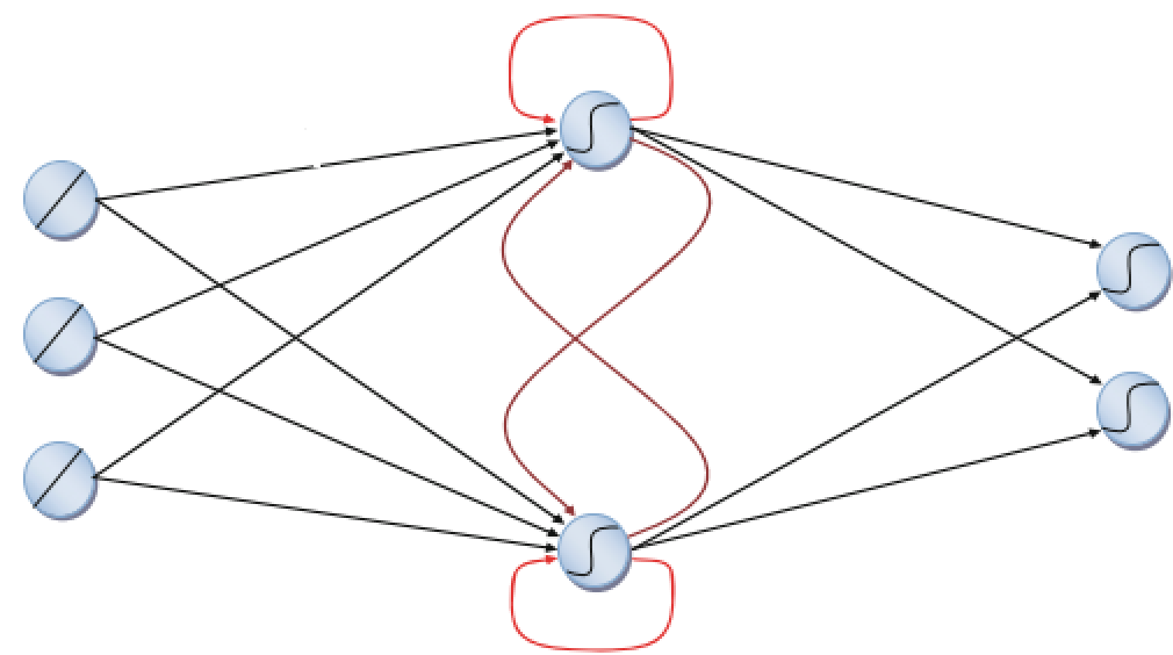

Figure 2.x: Recurrent Neuronal Network (Grum, 2022)

The figure above is a simplified visualization how the working principle. The blue points represent the neurons with connections between them. The processing order is from left to right. What makes this kind of network special are the red connections. The dark red connections are between the same layer level, the brighter red connections are to a neuron itself. This can lead to processing of a specific information for several times. It can even be transferred between different neurons a layer for several times, which makes an information available a longer time. This is what equals the network to the short-term memory.

### Summary Neuronal Networks

For Human it is often easy to acquire a series of data. The challenge of artificial neuronal networks is to provide the computer with the information. It is also required to process as much raw data as possible, without giving many rule bases. The result should be software that is capable of learning from data, extract patterns and recognize them on new data.

Neuronal networks still have a lot of potential to be unlocked in future. Scientists researching on the matter for a while and still will. The main issues are that the inspiring model, the human brain, has a huge size with approximately 1011 neurons and that its hardly possible to access the human brain. But with ongoing research artificial neuronal networks will grow in power.

# METHODOLOGY

## Flow chart

## Description of the work

## How the Lernfarbrik works

The university Albstadt-Sigmaringen is using two neuronal networks to detect the current state of the learning factory. To make this possible it is necessary to preprocess all data in a way that you can apply a neuronal network onto it. How to preprocess the data in that manner is described in the following chapter.

First of all, the data is acquired by receiving messages from each topic, which are the different stations of the learning factory. Each message comes with several information, such as the time stamp, the station, an acknowledge code, an active or inactive state and an optional description and target. To get a set of data to work with, the ordering process is conducted once and the raw data is written into a JSON file and saved. Therefore, this data can be used in all of the following steps and it is not necessary to repeat an ordering process more often. A sample message from the high-bay warehouse is shown in the following figure.



Figure x.x: Sample message

The raw data is not sorted correctly corresponding to the time steps, so the first step for data preparation is to run a simple sorting algorithm. The reason for the data to be in the wrong order is that the distance between some recorded time stamps is less than a millisecond and during transmission they can get mixed up. Data is read from the JSON file and written into a list, then the time stamps is extracted from the messages and a list with two columns is created, where the time stamps are in the first column and the message in the second. Now the list is sorted alphabetically by the time stamps and the messages can be written in a new JSON file. An example is given in the figure below.

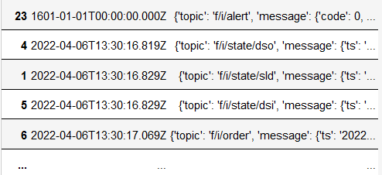

Figure x.x: Sorted messages

Now the raw data needs to be converted into a form that allows the models of the neuronal networks to work with it. The relevant data are the code, the active state and the target, which needs to be values from the same data type and range in order for the model to work efficient. Since the codes are either 0, 1 or 2 and the active state is either 0 or 1 it makes sense to also convert the target to small integer values. In this case 0 to 3 are used to represent the different targets. With that done there are only 13 input data with small integer values left. The starting values of each input is set to -1 and updated whenever a new message is received, then the integer values are written into a new file. The initial state is reached as soon as there is a message from each station.

Table x.x: Possible active state, code and target of each station

|  |  |  |  |
| --- | --- | --- | --- |
| station | active | code | target |
| vacuum gripper robot | 0, 1 | 1, 2 | 0, 1, 2, 3 |
| sorting line with color detection | 0, 1 | 1, 2 |  |
| multi-processing station with oven | 0, 1 | 1, 2 |  |
| high-bay warehouse | 0, 1 | 1, 2 |  |
| input station | 0, 1 | 0, 1 |  |
| output station | 0, 1 | 0, 1 |  |

The data is provided in the following order:

hbwstate, hbwcode, vgrstate, vgrcode, vgrtarget, mpostate, mpocode, sldstate, sldcode, dsistate, dsicode, dsistate, dsocode

Next, every state that is possible during an ordering process has to be determined. This is achieved by sorting out all identical states, but only the consecutive ones, as well as all states that have a -1 in it. Then the remaining states have to be labeled manually, because otherwise the model would not now what they mean. For example the initial state (0, 1, 0, 1, 0, 0, 1, 0, 1, 0, 1, 0, 1) is found twice in that list because it occurs at the beginning as well as at the end of a ordering process.

If two or more states are represented by the same data, they have to be summarized under one name. This happened twice in the previous labeling so it has to be changed to a meaningful common name. Now there are 9 states left, which are easy to process in the model. Lastly the states also need to be assigned to corresponding integer values.

When all the data preparation and preprocessing is done, they can finally be loaded into the model of the neuronal networks. At first the convolutional neuronal network (CNN) is used and then a recurrent neuronal network (RNN) is applied.

For the CNN the data has to be separated into input and output data. As input the 13 values of the stations are used and for output the 9 states, which are put in a 1D-array.

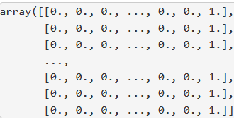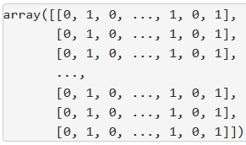

Figure x.x: Input array (left) and output array (right)

The following step is to set the definitions for the sequential model of the convolutional neuronal network. The model consists of 13 input neurons and 1 dias neuron that fires random values to ensure the model will not specify too much. A hidden layer with 10 neurons is added to the model as well as the 9 output neurons and the activation functions are defined. When the model is fully defined it has to be configured using a compile function, where the standard optimizer is chosen.

When training the model with the input and output data, the results shows that it gets better and better for each epoch. After 100 epochs the accuracy is >99% and the mean absolute error is <2%. After 200 epochs the accuracy reaches 100% and the mean absolute error is near 0% and from then on, the improvements are neglectable. When the model is now tested with sample input data is it expected that it always gives the correct result.

For the RNN the previous states are also put into consideration, leading to a faster and more precise result. The output data is the same as for the CNN put the input data has to be processed further as a 1D-array is not enough for the RNN. A multidimensional array with as many the previous states as wanted is created.

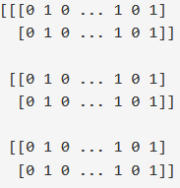

Figure x.x: Multidimensional input array

For model definition a different input layer called long short-term memory is required, which contains the 13 neurons, the dias neuron plus the previous states.

The model training follows the same procedure as for the CNN, but the results are worse this time, because after 500 epochs the accuracy is about 98% and the mean absolute error 2%. It seems like the RNN does not suit the application as well as the CNN does. When tested with the same sample data the results are also correct which indicates that the RNN is still good, but there are some issues with transitions between the output states.

# RESULTS AND DISCUSSION

## MES – Explanation of dashboard

## What can you learn from Lernfabrik?

## Implementation Consulting

This chapter will analyze what needs to be done in future to use the learning factory in full extent. It will be shown which hardware needs to be acquired, and what software is missing.

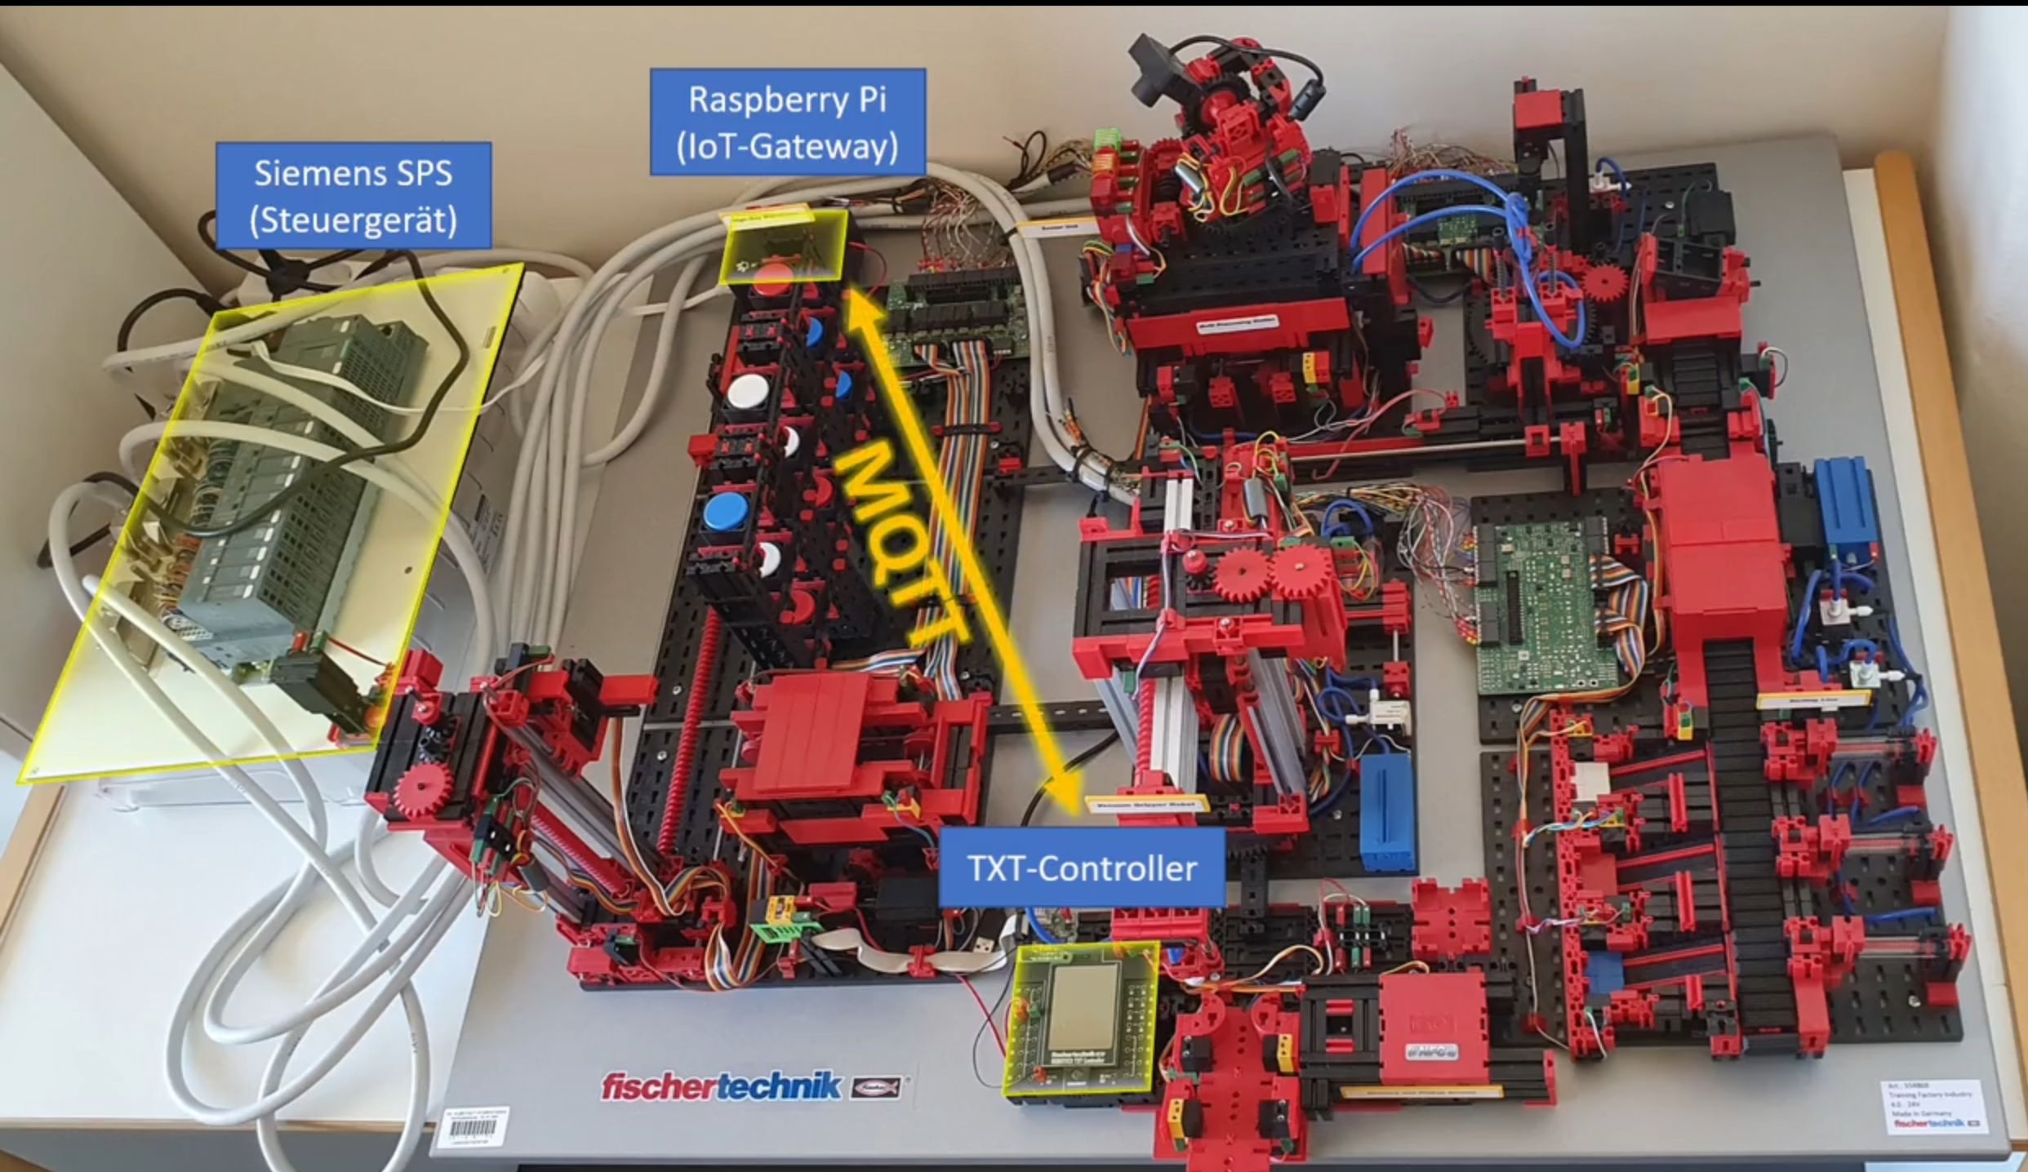

Siemens PLC

Figure 4.x: Controller Overview (Klein, M., <https://www.hs-albsig.de/studienangebot/wissenschaftliche-weiterbildung/osteraktion/osteraktion-12-lernfabrik/?sword_list%5B0%5D=lernfabrik&no_cache=1>)

The figure above shows the prototype of the factory. All the parts not highlighted can be found in the factory of the Innovation-Lab. The order elements are discussed in the following.

The purple highlighted parts are a combined sensor station. It is located on top of the oven, which is already part of the labor’s factory. The biggest sensor of the station is a camera. It is capable of 360° filming. This is used for a web based remote control. The camera is not integrated in the software that controls the factory. It is meant for enabling persons far away from the factory to take a look. Environment sensor make up the other sensors of the station. The built in sensors are for measuring:

* Brightness
* Temperature
* Humidity
* Air quality

These values of these sensors get collected and analyzed. They help to monitor the factory. With them, one can make sure that the production process is always within limits.

Highlighted by the green circle is the delivery station. The whole station is missing. It is used for incoming as well as outgoing goods. It consists of several elements. At the end of the production the gripper puts the workpiece into the delivery space. A light barrier is activated hereby. This information is collected by the controlling script. The information is then processed with all the other station data through the preparation steps to analyze it with the neuronal network. The missing information will be seen as an interruption to the production and a danger of a hang-up in the software.

In the following step the gripper puts the workpiece onto an color sensor. It detect the color of the product. The color information is also stored. As soon as the workpiece is back into the storage, the software knows which color it has. During ordering a customer can select the wished color. The software is able to get a matching product.

In the final step of the delivery station a NFC reader and writer tags the workpiece with the production information. This is important that the workpiece “knows” what it is. Thus this step is used as a simulation to real world factories, the NFC chip of the workpiece is not read again. Meaning it is a nice to have feature for the factory simulation, but not necessary for the neuronal network.

Attached to the delivery station is the Fischertechnik txt controller. Its purpose is to collect all sensor information. After the data collection it is send to the IoT-Gateway via MQTT standard. There is no specification which chip has been used. There is also no information about the used software. This makes it hardly possible to rebuild this element.

The IoT-Gateway receives the data from the txt controller. The hardware used is a Raspberry PI. It has two purposes. The first purpose is to control the ordering process. The software used for this is the python script that was introduced in the course. The second purpose is to transmit the factory data to the cloud. This is handled with the OPC UA protocol. In the cloud the source code for the neuronal network is running. So this connection is crucial to hand the production information to the neuronal network.

# CONCUSSION AND RECOMMENDATIONS

**‘Heading 1’** is used for the chapter such as INTRODUCTION, LITERATURE REVIEW etc.

## Title (use Heading 2 style)

This is where you start your writing. Use ‘Normal’ style to write in this section.

### Title (use Heading 3 style)

This is where you start your writing. Use ‘Normal’ style to write in this section.

REFERENCES

|  |
| --- |
| Hebb, D. O.. *The Organization of Behavior*. 1st Ed. New York. Psychology Press. 2002 |
| Picton, P.. *Introduction to Neural Networks*. 1st Ed. London. Red Globe Press London. 1994 |
| Ertel, W.. *Grundkurs Künstliche Inelligenz*. 5th Ed. Weingarten. Springer. 2021 |
| Grum, M..*Construction of a Concept of Neuronal Modeling*. Berlin. Springer. 2022 |
|  |
|  |
|  |
|  |